SOLITAIRE INFOSYS INC.

C-110, lndustrial Area, Phase 7, Mohali 160055, India

Library Management System

Software Training (BTCS-801)/Industry Oriented Project Training (BTCS-802)

**BACHELOR OF TECHNOLOGY**

(Computer Science and Engineering.)



FEB-JUNE, 2022

**SUBMITTED BY:**

Ankush

1816834

**Under the Guidance of**

Ms. Jyotinder Kaur

(Assistant Professor)

### DEPARTMENT OF COMPUTER SCIENCE AND ENGINEERING

### CHANDIGARH ENGINEERING COLLEGE JHANJERI, MOHALI

### Image result for PTU

**Affiliated to I.K Gujral Punjab Technical University, Jalandhar**

**(Batch: 2018-2022)**

### 

# CANDIDATE'S DECLARATION

### I “ANKUSH” hereby declarethat I have undertaken Semester Training at “SOLITAIRE INFOSYS INC.” during a periodfrom__04-02-2022__ to __04-08-2022__in partial fulfillment of requirements for the award of degree of B.Tech (Computer Science and Engineering) at Chandigarh Engineering College Jhanjeri, Mohali. The work which is being presented in the training report submitted to Department of Computer Science and Engineering at Chandigarh Engineering College Jhanjeri, Mohaliis an authentic record of training work.

(Student Signature with Date) (Mentor Signature with Date)

**ANKUSH Ms. Jyotinder Kaur**

Univ. Roll No🡪1816834 DESIGNATION, CSE

Semester:🡪 8

Signature of the Head of Department

(With Stamp)

**Dr. Sahil Vashisht**

**HOD CSE**



**Department of Computer Science & Engineering**

**Chandigarh Engineering College Jhanjeri, Mohali– 140307**



**Major Project Synopsis on**

Breast Cancer Prediction using Machine Learning



**Project Work under the supervision of**

**ANCHAL SINGH** Contact: 82880 06316 / [gagnslinfy@gmail.com](mailto:gagnslinfy@gmail.com)



**ABSTRACT**

Cancer neoplasm has discovered a varied condition of many varied subtypes. The timely tests and treatment of a cancer kind is currently a demand in timely cancer analysis as a result of it supports the medical treatment of patients. several analysis groups studied the appliance of cube-shaped CENTIMETERS and Deep Mastering strategies within the field of biomedicine and bioinformatics within the classification of parents with cancer across high- or low risk classes. These types of techniques have thus been used as a model for the growth and treatment of cancer neoplasm. As, it's very important that cube-shaped CENTIMETERS instruments will handle uncovering key options from complicated datasets. quite an few of those strategies square measure wide used for the discharge of prognosticative models for predicating a cure for cancer neoplasm, a number of the strategies square measure factory-made neural networks (ANNs), support vector machine (SVMs) and call trees (DTs). although we will perceive cancer progression with the utilization of mil strategies, a satisfactory validity levels is required to require these strategies into mind in skilled practice a day. On this study, the mil & metric capacity unit approaches utilized in cancer progression building square measure reviewed. generally the predictions addressed square measure largely coupled to specific mil, source, and information tiny sample management.

**LIST OF FIGURES**

|  |  |  |
| --- | --- | --- |
| **Fig. No.** | **Figure Name** | **Page No.** |
| **Fig.** 2.1 | Tumors are represented as X and classified as benign or malignant | 17 |
| **Fig.** 2.2 | An indicative ROC curve of two classifiers | 18 |
| **Fig.** 2.3 | An illustration of the ANN structure | 20 |
| **Fig.**2.4 | Block diagram of the breast cancer recognition system | 22 |
| **Fig.**3.1 | Technologies used for breast cancer detection | 24 |
| **Fig.3.2.1** | Comprehensive study on cancer detection using biosensors | 26 |
| **Fig.**3.2.2 | Comprehensive study on breast cancer detection using machine learning | 26 |
| **Fig.**3.2.3 | Process flow | 27 |
| **Fig.** 4.1 | Decision Tree Algorithm | 29 |
| **Fig.**5.1 | Data Exploration | 32 |
| **Fig.** 5.2 | Pairplot of breast cancer DataFrame | 33 |
| **Fig.**5.3 | Count Target Class | 34 |
| **Fig. 5.4** | Info OF Data | 35 |
| **Fig. 5.5** | correlation of barplot | 36 |
| **Fig. 5.6** | counter plot of feature mean radius | 37 |
| **Fig. 5.7** | Heatmap of DataFrame | 38 |
| **Fig. 5.8** | Heatmap of Correlation of breast cancer DataFrame | 39 |
| **Fig. 5.9** | LOGISTIC REGRESSION | 40 |
| **Fig. 5.10** | K-Nearest Neighbor Classifier | 40 |
| **Fig. 5.11** | Naive Bayes Classifier | 40 |
| **Fig. 5.12** | Decision Tree Classifier | 40 |
| **Fig. 5.13** | Random Forest Classifier | 41 |
| **Fig. 5.14** | AdaBoost Classifier | 41 |
| **Fig. 5.15** | XGBOOST CLASSIFIER | 41 |
| **Fig. 5.16** | Classification Report of Model | 41 |
| **Fig 5.17** | Cross-Validation of ML Model | 42 |

**TABLE OF CONTENTS**

|  |  |  |
| --- | --- | --- |
|  | Candidate Declaration  Acknowledgement  Abstract  List of figures  Table of Content | I II III IV V  VIII |
| 1. | INTRODUCTION | 9-16 |
| 2. | INTRODUCTION TO THE PROJECT | 17-22 |
|  | 2.1Fig of classification task in supervised learning | 17 |
|  | 2.2 Fig of an indicative ROC curve of two classifiers | 18 |
|  | 2.3 Fig of an illustration of ANN structure | 20 |
|  | 2.4 Block Diagram of the Breast Cancer Detection | 22 |
| 3. | Advanced technology in Breast Cancer Detection | 23-26 |
|  | 3.1 Technologies used in Breast Cancer Detection | 23 |
|  | 3.2 Breast Screening Techniques | 24 |
|  | 3.2.1Biosensors | 24 |
|  | 3.2.2 Biosensors using breast cancer detection | 24 |
|  | 3.2.3 Process Flow | 26 |
| 4. | Data Mining and Machine Learning | 27-31 |
|  | 4.1 Decision Tree Algorithm | 27 |
|  | 4.2 KNN Algorithm | 28-29 |
|  | 4.3 Support Vector Machine(SVM) | 29-30 |
|  | 4.4 Hyperplanes and Support Vectors | 30 |
|  | 4.5 Naïve Bayes (NB) It is a probabilistic classifier | 30-31 |
|  | 4.6 Logistic Regression | 34-35 |
| 5. | Data Exploration | 35-45 |
|  | 5.1 Read the data from the top | 35 |
|  | 5.2 Pairplot of breast cancer DataFrame | 36 |
|  | 5.3 Count Target Class | 37 |
|  | 5.4 Information of Data | 38 |
|  | 5.5 Correlation of Barplot | 39 |
|  | 5.6 Counter plot of feature mean radius | 40 |
|  | 5.7 Heatmap of Dataframe | 41 |
|  | 5.8 Heatmap of Correlation of breast cancer Dataframe | 42 |
|  | 5.9 Logistic Regression | 43 |
|  | 5.10 K-Nearest Neighbor Classifier | 43 |
|  | 5.11 Naïve Bayes Classifier | 43 |
|  | 5.12 Decision Tree Classifier | 43 |
|  | 5.13 Random Forest Classifier | 44 |
|  | 5.14 AdaBoost Classifier | 44 |
|  | 5.15 XGBOOST Classifier | 44 |
|  | 5.16 Classification Report of Model | 44 |
|  | 5.17 Cross-Validation of ML Model | 45 |
| 6. | CONCLUSION & FUTURE SCOPE | 46 |
|  | 6.1 CONCLUSION | 46 |

|  |  |  |
| --- | --- | --- |
|  | 6.1 FUTURE SCOPE | 46 |
| 7. | References | 47-48 |



**1. INTRODUCTION**

**1.1 PROJECT REQUIREMENTS:**

* Python Programming language
* NumPy
* Pandas
* Matplotlib
* Sklearn for Machine Learning Algorithms
* TensorFlow and Keras for Model Training

**PYTHON PROGRAMMING LANGUAGE**

Python is a broadly useful deciphered, intelligent, object-situated, and undeniable level programming language. It used to be made by involving Guido van Rossum for the term of 1985-1990. Like Perl, Python supply code is also reachable underneath the GNU General Public License (GPL). This instructional exercise offers more than adequate insight on Python programming language.

**WHY PYTHON IS IMPORTANT**

Python is a MUST for undergrads and working experts to develop to be a great Software Engineer especially when they are working in Web Development Domain. I will be posting down a portion of the critical favors of getting to know Python are as follows:

* **Python is Interpreted:** The mediator approaches Python at runtime. You would rather not develop your program. This is tantamount to PERL.
* **Python is Object-Oriented:** Python supports Object-Oriented style or technique of programming that encapsulates code within objects.



**PECULIARITY OF PYTHON**

* It helps useful and structured programming strategies as properly as OOP.
* It can be used as a scripting language or can be compiled to byte-code for constructing giant applications.
* It presents very high-level dynamic facts kinds and helps dynamic kind checking.
* It helps automated rubbish collection.
* It can be without difficulty built-in with C, C++, COM, ActiveX, CORBA, and Java.

**APPLICATIONS OF PYTHON**

* Simple to-learn − Python has not many catchphrases, simple design, and a really depicted punctuation. This allows the researcher to select up the language rapidly.
* Simple to-peruse − Python code is extra essentially depicted and seen to the eyes.
* Simple to-keep up with − Python's stock code is quite simple to-keep up with.
* An immense well-known library − Python's main part of the library is truly movable and cross-stage appropriate on UNIX, Windows, and Macintosh.



* Intelligent Mode − Python has help for an intuitive mode which allows in intelligent looking at and investigating of pieces of code.
* Compact − Python can run on a wide scope of equipment structures and has the indistinguishable connection point on all stages.
* Extendable − You can add low-level modules to the Python translator. These modules permit developers to add to or customize their gear to be more noteworthy effective.
* Information bases − Python offers connection points to all fundamental modern data sets.
* GUI Programming − Python helps GUI purposes that can be made and ported to numerous device calls, libraries and home windows frameworks, like Windows MFC, Macintosh, and the X Window gadget of Unix.
* Adaptable − Python presents a higher shape and help for monstrous bundles than shell prearranging.

**NUMPY MODULE**

NumPy, which represents Numerical Python, is a library comprising of complex exhibit objects and a progression of schedules for handling these clusters. Utilizing NumPy, numerical and sensible procedure on clusters can be performed. This instructional exercise makes sense of the essentials of NumPy like its design and climate. It furthermore examines the in excess of a couple of exhibit capacities, kinds of ordering, and so forth.

NumPy is a Python bundle. It means 'Mathematical Python'. It is a library comprising of complex exhibit objects and a progression of schedules for handling of cluster.Numeric, the precursor of NumPy, used to be created with the guide of Jim Hugunin. One more pack Numpy array used to be furthermore evolved, having a few additional



functionalities. In 2005, Travis Oliphant made NumPy group by utilizing consolidating the elements of Numpy array into Numeric bundle. There are numerous supporters of this open stockpile project.

**OPERATIONS OF NUMPY**

Utilizing NumPy, a designer can work the accompanying tasks −

Numerical and intelligent procedure on exhibits.

Fourier changes and schedules for structure control.

Activities related to direct variable-based math. NumPy has in-fabricated highlights for direct polynomial math and arbitrary assortment age.



**NumPy – A REPLACEMENT MatLab**

NumPy is often utilized close by with applications like SciPy (Scientific Python) and Matplotlib (plotting library). This total is broadly utilized as a substitute for MatLab, a well-known stage for specialized processing. Notwithstanding, Python decision to MatLab is currently considered as a more prominent contemporary and entire programming language.

It is open source, which is a presented advantage of NumPy.

**PANDAS MODULE**

Pandas is an open-source Python Library introducing superior execution data control and assessment gadget the use of its powerful realities structures. The distinguish Pandas is gotten from the expression Panel Data - an Econometrics from Multidimensional information.

In 2008, designer Wes McKinney started making pandas when in need of unnecessary execution, bendy gadget for investigation of information.

**KEY FEATURES OF PANDAS**

* Quick and climate amicable DataFrame object with default and uniquely designed ordering.
* Apparatuses for stacking realities into in-memory data objects from stand-out document designs.
* 
* Information arrangement and inherent managing of lacking information.
* Reshaping and turning of date sets.
* Name based cutting, ordering and subsetting of enormous insights sets.
* Sections from a measurements shape can be erased or embedded.
* Bunch through measurements for total and changes.
* High generally speaking execution combining and turning into an individual from of information.
* Time Series usefulness.

**BENEFITS OF PANDAS**

The advantages of pandas over utilizing other language are as per the following:

Information Representation: It addresses the information in a structure that is appropriate for information investigation through its DataFrame and Series.

Clear code: The reasonable API of the Pandas permits you to zero in on the center piece of the code. Along these lines, it gives clear and succinct code to the client.



**PYTHON PANDAS DATA STRUCTURE**

The two main knowledge structures in Pandas are Series for 1-D knowledge and DataFrame for 2-D knowledge. knowledge in higher dimensions are supported among DataFrame employing a conception referred to as stratified assortment. For storing axis labels of Series and DataFrame, the info structure used is Index. These knowledge structures is created from Python or NumPy knowledge structures. Pandas knowledge structures store knowledge exploitation NumPy or Pandas knowledge varieties. Pandas has outlined new knowledge varieties wherever NumPy knowledge varieties do not satisfy specific use cases. Pandas knowledge varieties are referred to as Extension varieties. they are extended from Pandas array. Developers will extend array to make custom knowledge varieties.

Pandas includes ways to convert knowledge structures from Pandas to Python or NumPy. there is additionally implicit or express conversion {of knowledge | of knowledge | of information} varieties since a Series object or a DataFrame column will store values of just one data sort. Dataframe in pandas is one step prior series (since it's a 1 dimensional knowledge structure). Dataframe may be a 2nd system having tagged axes as rows and columns. so as to make a dataframe, we'd like to invariably work around 3 main aspects:

* Data (Source to populate our dataframe with)
* Rows (Horizontal wise)
* Columns (Vertical wise)

### 

### Panel in Pandas

### Panel in pandas is employed for operating with third-dimensional information. it's not used that abundant in universe examples. But, let’s say that you just have sets of dataframes and you wish to research all of them in one go, then you'll be able to use the choice of panel in pandas.

The Pandas gives two information constructions to handling the information, i.e., Series and DataFrame, which are examined underneath:

**Series:**

It is a **one-layer** cluster that is **capable of** putting away different **types of information.** The list is the column marks of the **series.** We can change over the rundown, tuple, and word reference into **a series.** A series can't **have many segments.** It has **a single boundary.**

Data: It can be any rundown, word reference, or scalar worth.

**PYTHON PANDAS DATAFRAME**

It is a broadly utilized information construction of pandas and works with a two-layered cluster with named tomahawks (lines and sections). DataFrame is characterized as a standard method for putting away information and has two unique files, i.e., line file and segment record. It comprises of the accompanying properties:

The sections can be heterogeneous sorts like int, bool, etc.

It tends to be viewed as a word reference of Series structure where both the lines and segments are recorded. It is signified as "segments" if there should arise an occurrence of segments and "record" in the event of lines.



MATPLOTLIB MODULE

Matplotlib is a Library used for plotting graphs in the Python programming language. It is used plot 2 - dimensional arrays. Matplotlib is built on NumPy arrays. It is designed to work with the border SciPy stack. It was developed by John Hunter in 2002.

The advantage of representation is that client can have visual admittance to a lot of the dataset. Matplotlib is a library which is comprises of different plots like histogram, bar, line, dissipate, and so on

Matplotlib accompanies a gigantic assortment of plots. Plots are useful for getting examples, patterns and for making relationships. It has instruments for thinking about quantitative data.

As matplotlib was the absolute first library of information representation in python, numerous different libraries are created on top of it or intended to work corresponding to it for the investigation of the dataset.

## 

## INTRODUCTION OF BREAST CANCER

Breast cancer is the most common type of cancer in women worldwide. Cases of deaths have been reported in many rural and urban areas. Doctors use conventional therapies such as mammography, imaging ultrasound, MRI, biopsy, fine aspiration cytology etc. to diagnose breast cancer. The effectiveness of the diagnosis is reduced by various man-made errors such as differences between performance and internal functioning, fatigue, physician experience. Therefore, in order to diagnose a fatal disease, including breast cancer, a reliable second opinion is a must. The advent of computer-assisted diagnostic tests (CAD) by various machine learning units is a promising method that can help a radiologist to determine and predict cancer cells in the patient's body.



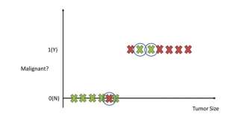

**Fig. 2.1 Classification task in supervised learning. Tumors are represented as X and classified as benign or malignant. The circled examples depict those tumors that have been misclassified**

Much research has been done in the field of CAD through machine learning. Most of the reported separation strategies are monitored when a predefined label is present to assess the accuracy of the specialist system. The Wisconsin Breast Cancer Web site (WBCD) from the UCI machine learning area is a standard data set, used as part of various investigations to validate the seizure of a segment separator. In this case, the authors used an encrypted monitoring algorithm with 10 times the verification protocol and achieved 95.57% accuracy. In, the authors proposed a genetic algorithm (GA) based on different rules for diagnosing breast cancer. They found the best intermediate category accuracy (96.995%) compared to PolyAnalyst, a commercially

 available data mining tool. In, machines supporting a small square vector (LS-SVM) were used and 98.53% accuracy was achieved with a 10-fold cross-sectional confirmation protocol. A new hybrid model of artificial antibodies with a neighbor close to k presented with a breast cancer diagnosis and 10-fold verification obtained 99.14% stage accuracy.

In, the authors capture breast cancer patterns in two phases, retrospective analysis to eliminate trivialities and discrete particle swarm optimization (PSO) to distinguish the sample between negative and negative. They found 98.71% accuracy. Two different classification techniques were compared and concluded that a radial basis function neural network (RBFNN) classifier is

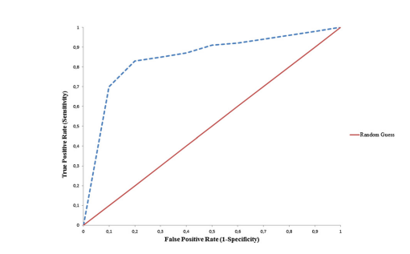

**Fig. 2.2 An indicative ROC curve of two classifiers: (a) Random Guess classifier (red curve) and (b) A classifier providing more robust predictions (blue dotted curve).**

better than a vector support device (SVM) with polynomial order 2 for breast cancer separation. They found intermediate accuracy between 96.56% of RBFNN and 92.13% of SVM with triple-point authentication. In, the incorrectly set feature selection method used with SVM as 99.41%

****division and separation accuracy (50-50% training component), 100% (70-30% and 80-20% training test component) achieved. In the authors, the authors used an artificial meta-plasticity multilayer perceptron (AMMLP) algorithm in the WBCD with an experimental training protocol of 60-40% and achieved 99.26% accuracy. A new SVM kernel method known for combining Gaussian RBF and polynomial kernel was introduced and 99.88% accuracy was found.

Emergency sensitivity networks (ANN) and SVM performance of small mathematical calculations (MCCs) in mammogram were examined. Internally, the authors proposed a mixed-choice approach that combined organizational rules with principal component analysis (PCA) for breast cancer detection and obtained a 99.29% accuracy of the ANN phase when using a 10-fold cross verification protocol. A clever mixing method for feature selection using comparisons of quantitative quantities is presented in the case where the labels of the actual class database are missing. This approach gave the impression of unchecked reading and proved to be better than most filters and methods based on wrapping. In, the authors used the K-means algorithm for genetic selection and later abridged features were used to classify breast cancer by SVM

category. They achieved a breakthrough of 97.38% division of the 10-fold cross-validation protocol. Authors from, using a new, Genetically Optimized Neural Network (GONN) model for severity problems and the WBCD website with the best 99.26% accuracy were obtained with a 10-fold verification program. Recently, Rotation Forest with GA as a feature selection system



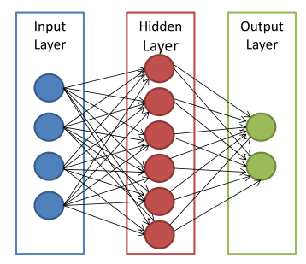

**Fig. 2.3 An illustration of the ANN structure. The arrows connect the output of one node to the input of another.**



was introduced. In the 14 key areas of the Wisconsin diagnostic website, they have achieved a high efficiency of 99.48%. Also, the authors model a well-designed Gauss-Newton novel based on algorithm (GNRBA). They calculate the correct weight coefficients for critical training to reduce computer complexity. They achieved a high 100% accuracy of 70-30% training test segmentation.

In short, the authors have used schemes such as GA, PCA, retrospective analysis, rough setting method, K-means algorithm and more recently, a jungle with GA with the appropriate function for selecting features. To differentiate, they use an unambiguous integration algorithm, a SVM with characters, a close neighbor k, a direct PSO, GA, a hybrid integration method and neural network methods. The highest-grade accuracy is 100%. However, studies that report 100% accuracy have used data classification protocol to test segmentation. Data classification protocol

is not widely accepted by the research community because it does not provide a better standard of practice. Although easy to use, it is statistically less powerful. Although the literature has provided sufficient information on the current and advanced technology for each individual to

detect breast cancer, we feel the need to use a method to select complex features in this work. Next, in line with the feature filtering method, summarizing and comparing the performance of

other well-known CAD tools on the basis of various operational measures will provide a clear picture for future researchers in the field.

Propels in logical administrations contain security and recovery of advanced clinical information of patients and gadgets included. Harmful blast region has ordinarily been a test in the finding and cure chart for hematological ailments. By and by, an amazing level of the general population is affected through no less than one disorders. Late years have seen enormous advances in logical science. Regardless of these movements, there is at this point an awesome shortfall of realities among the standard populace as for prosperity and contamination. A sizeable degree of the general population perhaps trips the evil impacts of logical issues, some of which could even be lethal. As appropriately as dealing with the precision of the

fast area of destructive conditions, embracing safeguarded, commonsense strategies and using current day development can recoil the prerequisite for watchmen and diminish by utilizing and huge logical administrations costs.

A combination of genetic and epigenetic **defects causes cancer.** The growth of the cells contributes to the **development of tumours.** If the cancer progresses quickly and spreads to other **parts** of the **body,** the disease may already be terminal. Bosom disease essentially influences ladies (with < 1% of cases influencing non-females); around one out of eight ladies foster bosom malignant growth in the course of their life. Generally, 2.1 million ladies are determined to have bosom malignant growth yearly, and the most seriously impacted are those between the ages of 40 and 70 years. Subsequently, the early conclusion of bosom disease is principal to great visualization. Notwithstanding the way that the side effects might be feeble in the beginning phases, chances of endurance drastically increment whenever recognized early. The different screening strategies used to analyze bosom malignant growth incorporate fine needle goal cytology (FNAC), ultrasound-directed careful biopsy, and mammography. In thick bosoms, the pace of disease discovery utilizing mammography is extremely poor and around 10%-30% of cases go undetected. It is vital to distinguish malignant growth cells precisely to diminish death rates, and this includes successful early disease analysis and therapy to build the endurance pace of malignant growth patients.



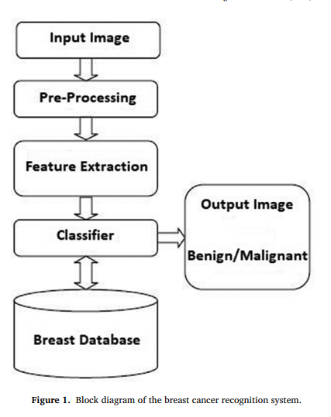

**Fig. 2.4 Block diagram of the breast cancer recognition system.**



**3.Advanced technology in breast cancer detection**

Innovative progression in the clinical area has persistently expanded throughout the long term. There are different advancements sent for bosom malignant growth location. The significant ones among these are introduced.

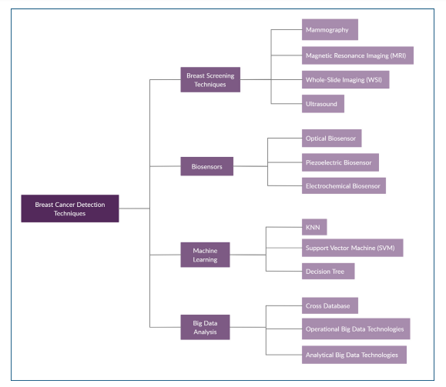

**Fig. 3.1Technologies used for breast cancer detection**



**3.2BREAST SCREENING TECHNIQUES**

Breast Screening refers to the early detection of illnesses by means of testing before signs appear. Genetic exams to discover inherited illnesses and physical or imaging-related examinations are all examples of testing that can be completed as phase of a screening test. Breast cancer screening involvesmodalities such as mammography, magnetic resonance imaging (MRI), whole-slide imaging (WSI), and ultrasound.

**3.2.1Biosensors**

Biosensors are scientific contraptions used to measure the natural attributes of tissues and physical make-up liquids. A few instances of biosensors comprise of optical biosensors, piezoelectric biosensors, and electrochemical biosensors.

**3.2.2Biosensors using breast cancer detection**

Biosensors have been created for of testing for bioanalytical particles in the space of designing, science, and science. Biosensors have two primary parts: a transducer that changes over biochemical reaction into quantifiable result signs, and (2) a bioreceptor on the sensor to catch the matching example. Biosensors work in a manner that can show the presence of irregularities inside the human body by distinguishing specific biomarkers inside the human body. By definition, a biomarker is a particle found in blood, tissues, or other body liquids that can be a sign of ordinary or unusual interaction, a condition, or a sickness. Ongoing examination on biomarkers has shown their importance in the discovery and treatment of an assortmentof diseases. Cancer biomarkers are viewed as the most important among other biomarkers.



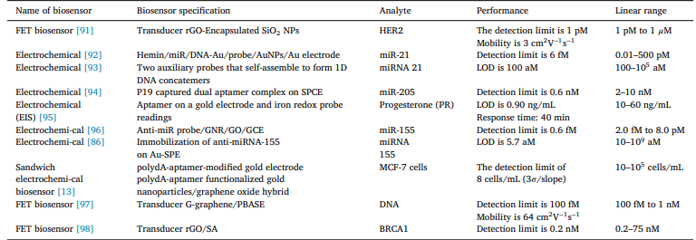

**Fig. 3.2.1 Comprehensive study on cancer detection using biosensors**

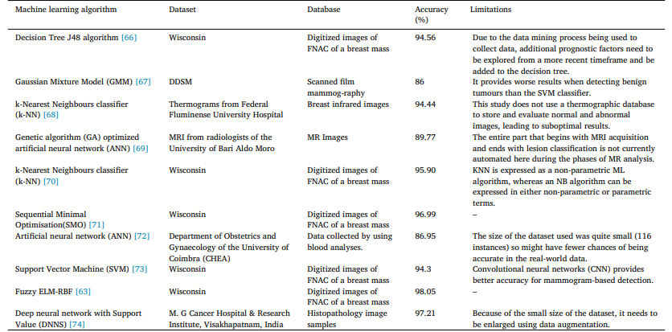

**Fig. 3.2.2Comprehensive study on breast cancer detection using machine learning**



**3.2.3.Process flow:**

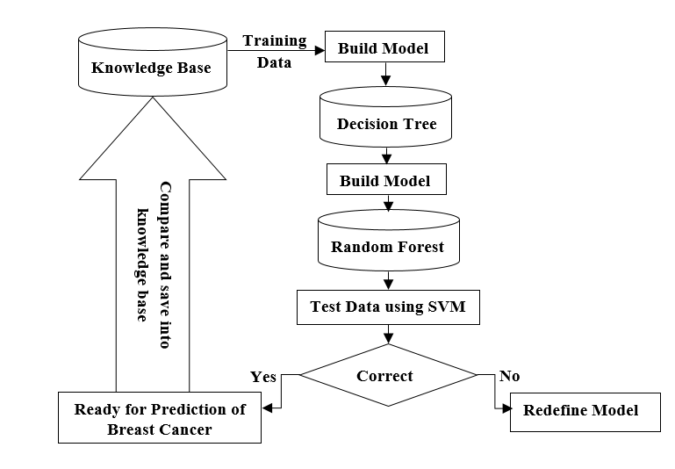



1. **DATA MINING AND MACHINE LEARNING**

The term "data mining" could also be a name, as a result of the goal is the extraction of patterns and data from giant amounts of knowledge, not the extraction (mining) of data itself. It is additionally a hokum and is usually applied to any kind of large-scale information or field of study (collection, extraction, deposit, analysis, and statistics) likewise as any application of laptop call network, including AI (e.g., machine learning) and business intelligence. The book information mining: Practical machine learning tools and techniques with Java[8] (which covers largely machine learning material) was originally to be named simply sensible machine learning, and additionally the term processing was solely another for marketing reasons. typically the

additional general terms (large scale) information analysis and analytics – or, once bearing on actual strategies, computing and machine learning – square measure additional applicable.

In this project we have a tendency to use the next machine learning algorithms:

**4.1 Decision tree algorithms :**

Decision tree algorithms are successful machine learning classification techniques. They are the supervised learning strategies that use information gained and cropped to enhance results. Moreover, call tree algorithms are ordinarily used for classification in several analysis, for instance, in the medicine space and health problems. There are several types of decision tree algorithms like ID3 and C4.5.However, J48 is that the most well-liked call tree algorithmic rule. J48 is the implementation of associate degree improved version of C4.5 and isan extension of ID3.

Selection Tree algorithm is one of the family of closely watched learning algorithms. Contrary to other supervised learning algorithms, the decision tree algorithm can be used for solving



regression and classification problems too. Typically the goal of by using a Decision Tree is to create a training model that can use to predict the category or value of the target changing by learning simple decision rules deduced from prior data(training data).

In Selection Trees, for guessing a class content label for a document we begin from the root of the tree. We compare the values of the root credit with the record’s attribute. On the basis of comparability, we follow the branch corresponding to that value and jump to the next node.

Choice trees classify the particular examples by selecting them down the particular tree from the particular root to many leaf/terminal node, with all the leaf/terminal node providing the particular classification in the illustration. Each node inside the tree provides a test case regarding some attribute, in addition to each edge climbing down from the client corresponds to the particular possible answers in order to the test situation. This process is usually recursive in characteristics and is recurring for every single and every single subtree rooted from the new client.

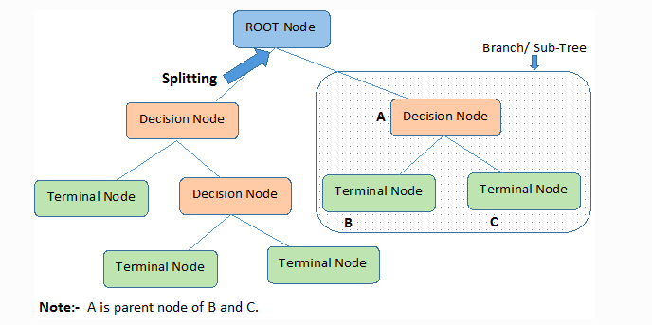



Decision Trees (DTs) area unit a non-parametric supervised learning methodology used for classification and regression. The goal is to form a model that predicts the worth of a target variable by learning straightforward call rules inferred from the info options. A tree may be seen as a piecewise constant approximation. For instance, within the example below, call trees learn from knowledge to approximate a sinusoid with a group of if-then-else call rules. The deeper the tree, the additional advanced the choice rules and therefore the fitter the model.

Decision trees can even be applied to regression issues, victimization the DecisionTreeRegressor category. As within the classification setting, the match technique can take as argument arrays X and y, solely that during this case y is anticipated to possess floating purpose values rather than number values. Decision trees and their ensembles ar standard ways for the machine learning tasks of classification and regression. call trees ar wide used since they're simple to interpret,

handle categorical options, reach the multiclass classification setting, don't need feature scaling, and ar able to capture non-linearities and have interactions. Tree ensemble algorithms like random forests and boosting ar among the highest performers for classification and regression tasks. MLlib supports call trees for binary and multiclass classification and for regression, victimization each continuous and categorical options. The implementation partitions knowledge by rows, permitting distributed coaching with millions or perhaps billions of instances. Users will realize a lot of data concerning the choice tree algorithmic rule within the MLlib call Tree guide. during this section, we have a tendency to demonstrate the Pipelines API for call Trees. The Pipelines API for call Trees offers a touch a lot of practicality than the first API. especially, for classification, users will get the anticipated likelihood of every category (a.k.a. category conditional probabilities). Ensembles of trees (Random Forests and Gradient-Boosted Trees) ar represented within the Ensembles guide.

Decision Trees area unit the muse for several classical machine learning algorithms like Random Forests, Bagging, and Boosted call Trees. They were 1st projected by Leo Breiman, a statistician at the University of Golden State, Berkeley. His plan was to represent knowledge as a tree wherever every internal node denotes a take a look at on associate degree attribute (basically a condition), every branch represents associate degree outcome of the take a look at, and every leaf node (terminal node) holds a category label. Decision trees area unit currently wide employed in several applications for prognosticative modeling, together with each classification and regression. typically call trees are spoken as CART, that is brief for Classification and Regression Trees. Let’s discuss in-depth however call trees work, however they are engineered from scratch, and the way we are able to implement them in Python.

Tree-based algorithms area unit a preferred family of connected non-parametric and supervised ways for each classification and regression. If you are curious what supervised learning is, it is the sort of machine learning algorithms that involve coaching models with information that has each input and output labels (in different words, we've information that we all know actuality category or values, and might tell the algorithmic rule what these area unit if it predicts incorrectly). The decision tree feels like an imprecise inverted tree with a call rule at the foundation, from that ensuant call rules unfolded below. for instance, a call rule are often whether or not someone exercises. There can even be nodes with none call rules; these area unit referred to as leaf nodes. Before we have a tendency to march on, let’s quickly scrutinize the various forms of call trees.

**4.2 K-nearest-neighbours (KNN) algorithm:**

It is a straightforward supervised learning algorithmic program in pattern recognition. It is one in every of the foremost in style neighborhood classifiers due to its simplicity and potency within the field of machine learning. KNN algorithmic program stores all cases and classifies new cases supported similarity measures; it searches the pattern area for the k coaching tuples that square measure nearest to the unknown tuples. The performance depends on the optimal range of neighbors (k) chosen, which is different from one information sample to a {different}. Typically the abbreviation KNN symbolizes “K-Nearest Neighbour”. This can be a supervised machine mastering algorithm. The modus operandi can be utilised to both category and regression difficulty statements.

The quantity of nearby neighbours into a fresh unknown variable of which predicted or categorised is denoted by simply the symbol ‘K’.



Let’s take some sort of good look on a related actual scenario before most of us get started having this awesome modus operandi.

We are typically notified that an individual share many attributes with your nearby peers, whether that be your pondering process, working etiquettes, philosophies, or different factors. As some sort of result, we build up friendships with most of us deem a lot like people.

The KNN modus operandi employs the exact same process. Its aim can be to locate each of the closest neighbours throughout regards to fresh unknown data level in order to be able to discover what category it belongs to be able to. It’s a distance-based approach.

KNN employs a mean/average method for forecasting the significance of new info. In line with the value regarding K, it could take into account all of the particular nearest neighbours. The

particular algorithm attempts in order to calculate the suggest for the nearest neighbours’ values until this has determined just about all the nearest friends within a specific array of the K benefit.

**4.3Support Vector Machine (SVM):**

It is a supervised learning technique derived from applied math learning theory for the classification of each linear and nonlinear knowledge. SVM classifies knowledge into 2 categories over a hyperplane at the same time avoiding over-fitting the information by maximizing the margin of hyperplane separating. “Support Vector Machine” (SVM) is a closely watched machine learning criteria that can be used for both classification or regression challenges. However, it is mostly used in classification problems. In the SVM algorithm, we plan

each data piece as a point in n-dimensional place (where n is many of features you have) with the importance of each feature being the value of a particular coordinate.

SVMs are different from other classification methods due to the way they choose your decision border that maximizes the distance from the closest data details of all the classes. Your decision border created by SVMs is called the maximum margin sérier or the maximum margin hyper

aircraft. The purpose of the support vector machine algorithm is to discover hyperplane in an N-dimensional space(N — the amount of features) that clearly classifies the data points. To

individual the two courses of data factors, there are many possible hyperplanes that could be chosen. Our objective is to find a plane that has the maximum perimeter, i. e the maximum distance between data points of both classes. Increasing the margin distance provides some encouragement so that future data points can be classified with more confidence.

## 4.4 Hyperplanes and Support Vectors

Hyperplanes are decision limitations that help sort out the data factors. Data points dropping on either part of the hyperplane can be credited to different courses. Also, the dimensions of the hyperplane depends on the number of features. When the number of input features is 2, then your hyperplane is simply a collection. If the quantity of input features is 3, then the hyperplane becomes a two-dimensional plane. This becomes difficult to imagine when the number of features exceeds 3.

Assistance vectors are data points that are closer to the hyperplane and impact the positioning and orientation of the hyperplane. Providing a few support vectors, we maximize the margin of the classifier. Deleting the support vectors will change the placement of the hyperplane. These are the points that help us build our SVM.



**4.5Naïve Bayes (NB) It is a probabilistic classifier:**

It is one of the foremost economical classification algorithms primarily based on applying theorem with robust (naïve) independent assumptions. It assumes the worth of the feature is freelance of the worth of the other options, given the class variable. Based on the maximum probability. It detects the class membership for the given tuple to a particular class.Naïve Thomas Bayes |mathematician} is also a probabilistic machine learning algorithm supported the Bayes Theorem, utilized during a giant kind of classification tasks. throughout this text, we'll understand the Naïve scientist algorithm and each one essential ideas. A Naive scientist classifier is also a probabilistic machine learning model that’s used for classification task. The crux of the classifier is based on the scientist theorem. Naive scientist falls beneath the umbrella of supervised machine learning algorithms that unit of measurement primarily used for classification. throughout this context, "supervised" tells usthat the algorithm is trained with every input choice and categorical outputs (i.e., the knowledge includes the correct desired output for each purpose, that the algorithm need to predict). The Naive Bayes classification formula may be a probabilistic classifier. it's supported chance models that incorporate sturdy independence assumptions. The independence assumptions usually don't have a bearing on reality. thus they're thought-about as naive. You can derive chance models by victimization theorem (credited to Thomas Bayes). reckoning on the character of the chance model, you'll be able to train the Naive Bayes formula in an exceedingly supervised learning setting.



Naïve Thomas Bayes models area unit ordinarily used as another to call trees for classification issues. once building a Naïve Thomas Bayes classifier, each row within the coaching dataset that contains a minimum of one sodium are going to be skipped utterly. If the check dataset has missing values, then those predictors area unit omitted within the likelihood calculation throughout prediction.

The Naive Thomas Bayes classification formula includes the probability-threshold parameter ZeroProba. the worth of the probability-threshold parameter is employed if one in all the higher than mentioned dimensions of the cube is empty. A dimension is empty, if a training-data record with the mix of input-field worth and target worth doesn't exist. The default worth of the probability-threshold parameter is zero.001. Optionally, you'll be able to modify the likelihood threshold. for instance, you'll be able to set the worth to zero.0002 by exploitation the subsequent command:

DM_ClasSettings()..DM_setAlgorithm('NaiveBayes','<ZeroProba>0.0002</ZeroProba>')

**4 Applications of Naive mathematician Algorithms**

Real time Prediction: Naive mathematician is Associate in Nursing eager learning classifier and it's positive quick. Thus, it may well be used for creating predictions in real time.

Multi category Prediction: This formula is additionally acknowledge for multi category prediction feature. Here we will predict the chance of multiple categories of target variable.

Text categorification/ Spam Filtering/ Sentiment Analysis: Naive mathematician classifiers largely utilized in text classification (due to higher end in multi class issues and independence rule) have higher success rate as compared to different algorithms. As a result, it's wide utilized in Spam filtering (identify spam e-mail) and Sentiment Analysis (in social media analysis, to spot positive and negative client sentiments)

Recommendation System: Naive mathematician Classifier and cooperative Filtering along builds a Recommendation System that uses machine learning and data processing techniques to filter unseen info and predict whether or not a user would really like a given resource or not.

**4.6Logistic regression**

In statistics, the logistical model (or logit model) is employed to model the likelihood of a definite class or event existing like pass/fail, win/lose, alive/dead or healthy/sick. this will be extended to model several categories of events like determinant whether or not Associate in

Nursing image contains a cat, dog, lion, etc. every object being detected within the image would be assigned a likelihood between zero and one and also the total adding to at least one. Logistic Regression was utilized in the biological sciences in early twentieth century. It was then utilized in several scientific discipline applications. logistical Regression is employed once the dependent variable (target) is categorical.

A hypothesis testing procedure within the multivariate analysis known as model utility take a look at is conducted to verify if there's a helpful relationship between the variable quantity and therefore the variable. The null hypothesis of the model utility take a look at refers to no helpful relationship between the dependent variable and therefore the variable. If null hypothesis is rejected, the predictor variable is taken into account to be helpful within the regression model. Devore stated that the regression model mustn't be used for more inferences such as predictions of future price or estimates of mean unless the model utility take a look at leads to rejection of null hypothesis for a fittingly little significance level of the take a look at, α.

The significance and handiness of model utility test in relapse investigation is notable. Many examinations connected with relapse included model utility test in their examination. Nonetheless, Woolston announced that an esteemed global logical diary has presently not acknowledged paper containing theory importance testing system in their examinations. The article of the diary stressed that invalid theory importance testing system is invalid. In theory

testing, p-esteem is a likelihood esteem that is utilized as a typical list for strength of proof. At the point when the p-esteem is less than 0.05, the outcome is announced 'genuinely huge'.



Whenever the p-esteem is under 0.01, the outcome is announced 'extremely huge'. The broadly utilization of p-esteem in the end turned into the most impressive authority of validity for numerous logical explores like testing the impact of qualities on conduct, the therapeutic powers of new medications or the wellbeing impacts of contaminations. Siegfried stressed that utilizing a p-esteem from a review to make any end has no intelligent premise. Siegfried questioned in the

event that p-worth can truly assist researchers with concluding whether an exploratory outcome is significant. In any case, a few analysts remarked that the choice of objecting in the utilization

of p-worth might have its own unfortunate results and hence the legitimate utilization of inferential techniques should be breaking down.

1. **Data Exploration**

We will initial go together with commerce the mandatory libraries and import our dataset to colab.research.google.com. We can examine the information set victimization the pandas’ head() method.

**5.1 df.head(7) {first 7 rows of the data}**

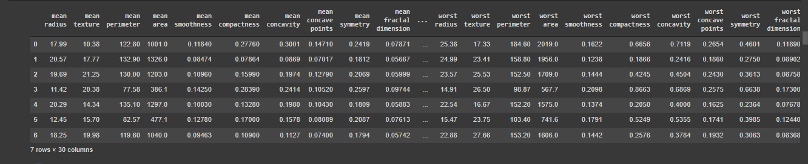



**5.2 Pairplot of breast cancer DataFrame**





**5.3 Count Target Class**

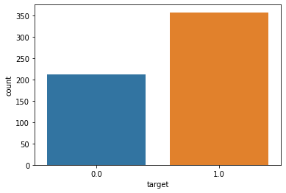



**5.4Info OF Data**

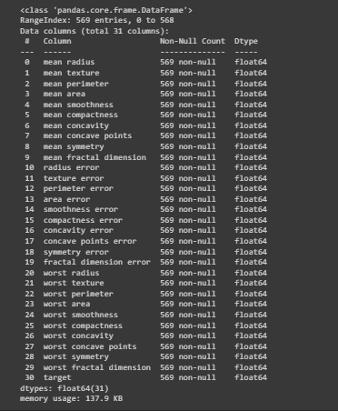



**5.5correlation of barplot**

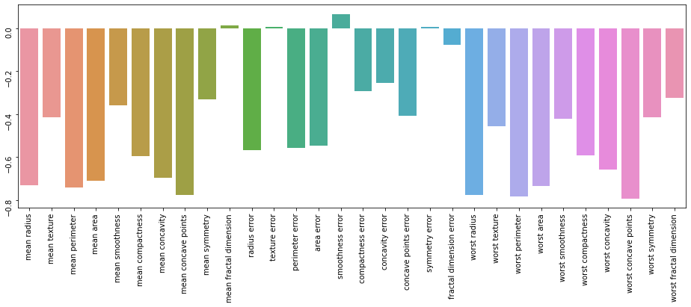



**5.6counter plot of feature mean radius**

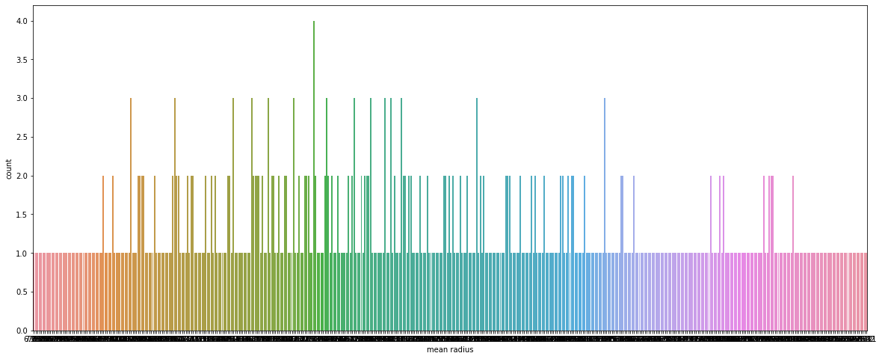



**5.7Heatmap of DataFrame**

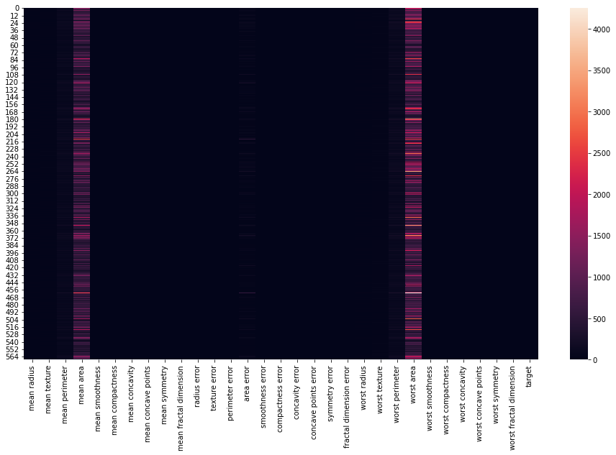



**5.8Heatmap of Correlation of breast cancer DataFrame**

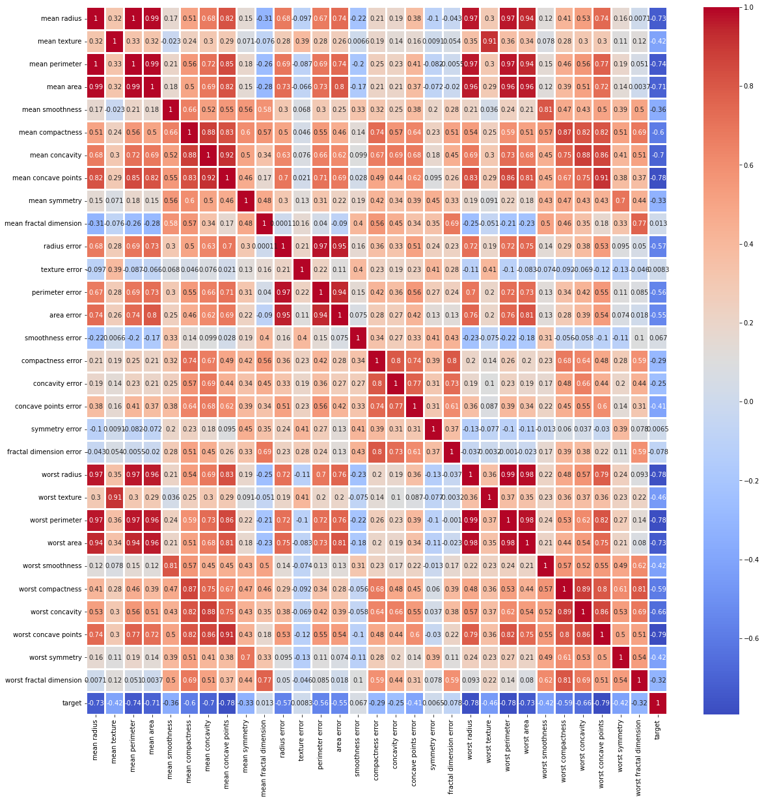



**5.9LOGISTIC REGRESSION**

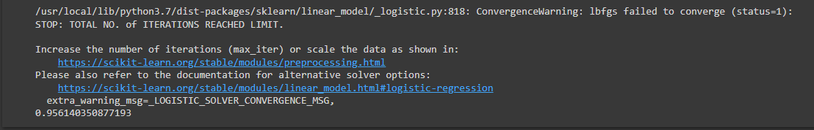



**5.10K-Nearest Neighbor Classifier**





**5.11 Naive Bayes Classifier**





**5.12 Decision Tree Classifier**





**5.13 Random Forest Classifier**



**5.14 AdaBoost Classifier**



**5.15 XGBOOST CLASSIFIER**





**5.16 Classification Report of Model**



**5.16 Classification Report of Model**

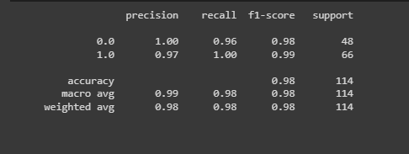

**5.17 Cross-Validation of ML Model**

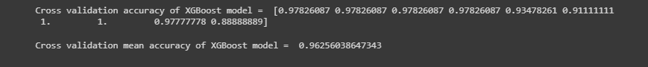



1. **Conclusion and Future Scope**

In this project in python, we tend to learned to make a breast cancer tumor predictor on the wisconsin dataset and created graphs and results for an equivalent. It has been ascertained that a decent dataset provides higher accuracy. choice of applicable algorithms with good home dataset can cause the event of prediction systems. These systems will assist in proper treatment ways for a patient diagnosed with carcinoma. There square measure several treatments for a patient supported carcinoma stage; data processing and machine learning may be a really sensible facilitate in deciding the road of treatment to be followed by extracting data from such appropriate databases. we mentioned the ideas of cc whereas we tend to printed their application in cancer prediction/prognosis. Most of the studies that are planned the last years and specialize in the event of prophetical models exploitation supervised cc strategies and classification algorithms reaching to predict valid unwellness outcomes. supported the analysis of their results, it's evident that the mixing of three-dimensional heterogeneous knowledge, combined with the applying of various techniques for feature choice and classification will offer promising tools for illation within the cancer domain.



1. **REFERENCE**
2. [https://www.who.int/cancer/prevention/dia gnosis-screening/breast-cancer/en/](https://www.who.int/cancer/prevention/dia%20gnosis-screening/breast-cancer/en/)
3. <https://towardsdatascience.com/building-a-simple-machine-learning-model-on-breast-cancer-data-eca4b3b99fa3>
4. Confusion Matrix: [https://tatwan.github.io/How-To-Plot-AConfusion-Matrix- In-Python/](https://tatwan.github.io/How-To-Plot-AConfusion-Matrix-%20In-Python/)
5. [**https://www.kaggle.com/datasets/merishnasuwal/breast-cancer-prediction-dataset**](https://www.kaggle.com/datasets/merishnasuwal/breast-cancer-prediction-dataset)
6. [**https://devopedia.org/pandas-data-structures**](https://devopedia.org/pandas-data-structures)
7. <https://devopedia.org/pandas-data-structures>
8. <https://machinelearningmastery.com/linear-regression-for-machine-learning/>
9. <https://www.kdnuggets.com/2020/01/decision-tree-algorithm-explained.html#:~:text=Decision%20Trees%20follow%20Sum%20of,form%20a%20disjunction%20(sum)>.
10. <https://www.analyticsvidhya.com/blog/2021/05/knn-the-distance-based-machine-learning-algorithm/>
11. <https://www.analyticsvidhya.com/blog/2017/09/understaing-support-vector-machine-example-code/>
12. <https://towardsdatascience.com/support-vector-machine-introduction-to-machine-learning-algorithms-934a444fca47>
13. <https://www.kdnuggets.com/2020/06/naive-bayes-algorithm-everything.html>
14. <https://towardsdatascience.com/naive-bayes-classifier-81d512f50a7c>
15. <https://blog.paperspace.com/introduction-to-naive-bayes/>
16. <https://scikit-learn.org/stable/modules/tree.html>
17. <https://spark.apache.org/docs/1.5.2/ml-decision-tree.html>
18. <https://blog.paperspace.com/decision-trees/>
19. <https://www.analyticsvidhya.com/blog/2017/09/naive-bayes-explained/>
20. <https://www.ibm.com/docs/en/db2/9.7?topic=classification-naive-bayes>
21. <https://docs.h2o.ai/h2o/latest-stable/h2o-docs/data-science/naive-bayes.html>